
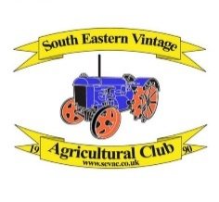
Vintage Tractors & Agricultural Machinery Display
30th & 31st August 2026

MARSHALS

We require marshals to escort the vehicles to and from the arena on the Sunday & Monday if you (or someone you know) could volunteer please complete and return this form
Available:- Both Days / Sunday / Monday

First Name ……………………………………………
Surname ……………………………………………
Address ………………………………………………………………………………………….
…………………………………………………………………Post Code……………………………...
Tel No………………………………… e-mail………………………………………………….

SIGNED………………………………………………………DATE…………………………………………

Please return this form with Stamped Addressed Envelope to

Abi Rusden
Broadbridge Stables abirusden@aol.com
Broadbridge Lane 07765 167482
Smallfield
Surrey
RH6 9RF

SEVAC, the organisers of this section, abide by the General Data Protection Regulation (GDPR) 2018. We do not sell, share or provide any information we hold about you to any other party. All information we hold is securely stored and only used to administer this section. Our full Privacy Policy is available on our website – www.sevac.co.uk/privacypolicy

