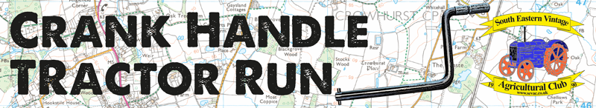
Organised by South Eastern Vintage Agricultural Club (SEVAC) in aid of charity.
Sunday 21st April 2024
Edenbridge and Oxted Showground, Tandridge Lane, Lingfield RH7 6LL
Registration between 9:30am - 10:30am

BOOKING FORM
Driver Information:
FULL NAME
FULL ADDRESS
DATE OF BIRTH
MOBILE NUMBER
EMAIL ADDRESS | ** Essential for any updates and communications nearer to the time **

Driver Declaration:
ALL DRIVERS MUST SIGN HERE TO CONFIRM THAT THEY HOLD A VALID DRIVING LICENCE AND RELEVANT INSURANCE.
DRIVERS SIGNATURE

Tractor Information:
TRACTOR MAKE/MODEL & COLOUR
TRACTOR REGISTRATION NUMBER

PLEASE CONTINUE OVERLEAF……

Tractor/Owner Information (to be completed if different than Driver Information):
TRACTOR OWNER NAME
TRACTOR OWNER ADDRESS
TRACTOR OWNER
MOBILE NUMBER
TRACTOR OWNER
EMAIL ADDRESS
ALL TRACTOR OWNERS MUST SIGN HERE TO CONFIRM THAT THEY CONSENT TO THE DRIVER NAMED ON PAGE 1, DRIVING THE TRACTOR AND THAT THE TRACTOR IS COVERED BY VALID INSURANCE
SIGNATURE OF TRACTOR OWNER

DECLARATION

I declare that during the whole period of this event that my vehicle entry will be fully road worthy and the vehicle is covered by adequate insurance for road use that includes Public Liability Insurance in accordance with the Road Traffic Act.

Only 1 passenger may travel on the tractor alongside the driver providing that there is a factory-fitted seat on the tractor.
I agree not to hold South Eastern Vintage Agricultural Club, Edenbridge and Oxted Showground or any of the organisers responsible for any loss or damage of any description throughout the event, to myself or the tractor entered, however caused.

I understand and I agree that I enter the event at my own risk and must follow the Highway Code throughout the route. I will also abide by the events health and safety regulations and rules on the day, along with directions from the marshals. I accept that the event will be photographed and filmed on the day.

I have read, and fully understand this declaration that by entering this event is wholly at my own risk and will abide by the conditions of entry.

I agree to produce licence and insurance documentation on the day, if requested by the organisers on the day.

Signed_____________________ Print Name_________________________ Date__________

Entry Information:

I enclose £10 for my tractor entry (cheques made payable to SEVAC)  I will include my name in the reference if paying by bank transfer | Paid by cheque | Paid by BACs
Send this entry form no later than 21st March 2024 to:
Crank Handle Run, The Thatched Cottage, Farleigh Court Road, Warlingham, Surrey, CR6 9PE
and either send a cheque or bank transfer to:
Account Name: SEVAC | Sort Code: 208813 | Account Number: 50086061

Things to note:
- Entries close on 21st March
- Registration on the day commences at 9:30am, closes at 10:30am
- Any communications before the day will be made via email

